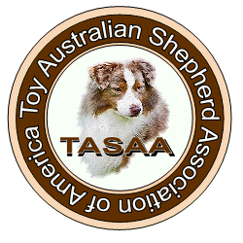

Rules and Regulations:

- Owners and Handlers MUST be members of TASAA in order to participate in the
TASAA National Specialty. Participation in the Mini Specialty does not require
TASAA Membership.

- Junior Handlers participating in the TASAA National Specialty must be TASAA
Junior Members – you may download the Membership Application from the
TASAA website.

3.Dogs entered in the Bred-By Exhibitor show must be handled in the initial class by
the breeder or breeder’s immediate family member. The dog/puppy may be handled
by someone other than the breeder in subsequent classes if the dog/puppy advances.

4.Dogs may be wicketed upon the judge’s discretion—dogs 14” and over
will be disqualified from the Toy National Specialty. Please assure that you have
entered the correct class/show.

5.The use of bait is allowed. However, please maintain a level of courtesy to other
exhibitors. Bait is not to be dropped purposefully in the show ring—exhibitors are
expected to pick up after themselves.

6. Class Descriptions shall be considered part of these rules.

7. Only Dogs or Bitches holding a TASAA Championship shall enter the Best of
Breed class.

